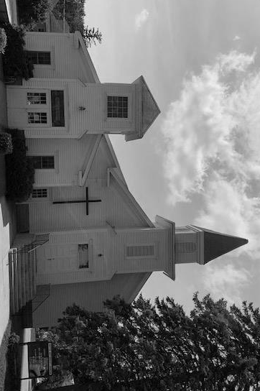
CLEARWATER UNITED METHODIST CHURCH NEWSLETTER - August 2021
Carol Halvorson, Editor,
clwtax@frontiernet.net
cell phone 320-493-4997

PRAISE GOD!
- For in person church services again-and masks not required!
- Coffee fellowship after church again!
- That we are blessed with not one but 2 able ministers!

OUR CHURCH WEBSITE:
www.clearwaterumcmn.org – Please remember to log in and check it out.
AUGUST BIRTHDAYS:
Leslie Newman-August 18
Pastor Ken Felska-Aug 27
Cassie Collins-August 29
If we are missing your birthday, please call, text or e-mail Carol and we will add.
FOR NEXT NEWSLETTER – Please send any announcements, articles, projects, thoughts, recipes, etc. to Carol.
If you would like to continue to receive the newsletter please send your e-mail to Carol. It would be very helpful.
ANNOUNCEMENTS:
IN-PERSON WORSHIP:
We went back to in person worship on March 14. Services are at 9:30 AM. Masks are now optional.
We have had some extra costs for church maintenance: Furnace and Air Conditioners: $906, a new sign insert for the ruined sign board – cost about $150, a new toilet for the out of service toilet, paint for the outside of the church will be approximately $400. New outdoor sign for church about $180. If anyone can help with these please designate the project on your offerings. Thank you.
WEEKLY BIBLE STUDY:
Mondays at 10:30 AM
UPCOMING EVENTS:
Saturday August 7- Celebration of Life for Verona Robinson at Clearwater United Methodist Church. Services will begin at 11 AM. There will be a chicken dinner to follow at the American Legion in Monticello.
Thursday August 12 – Social at the Kimball United Methodist Church with entertainment at 7:00 by Jumpin Jehosaphats and Sloppy Joes etc prior to entertainment. Contact Margaret for details.
Saturday August 14-movie night at church at 6:30 p.m.
Saturday August 28 from 1:00-4:00 p.m. Pastor Ken retirement get together at the Kimball United Methodist Church. Small program at 1:00 with fellowship to follow.
THANK YOU:
Thank you to Steve Houle and others who have been volunteering labor for needed church maintenance.
AD COUNCIL MEETING MINUTES JULY 6, 2021
Margaret read psalm 121, we talked about the meaning of the psalm.
Then the meeting was called to order by Pastor Alison.
Carol H. handed out copies of the treasurer’s report. We need more income, but we’ll be close to coming out even. WE do have some special repair projects to pay for. Our current balance is pretty good, thanks to the 2 PPP loans.
We discussed having a country concert with John Kurkosky
Playing and singing. Kitty will contact him to see if he is interested. We also might have him sing some Sunday too, possibly right after the Saturday night concert with ice cream social.
We also discussed doing something for Clearwater Days, if they have it.
Alison brought up Covid 19 healing. Kitty mentioned a movie night that would work for that healing. (August 14th was suggested, at 6:30 or 7:00)
Carol talked about the newsletter, and whether different people wanted it or not, email or snail mail. She went through a list with everyone, and removed a few names.
We discussed church cleaning, I will still do bathrooms, and see if Karen will also.
We talked about communion, we’ll probably have it on Sunday, and continue to use the disposable cups we have been using, since we have some left.
We talked about having the choir singing again, we are going to sing this week, a communion song, with the congregation.
Margaret brought up changing the light bulbs in the sanctuary.
Pastor Alison closed the meeting with prayer.
Secretary, Diane Miller

RECIPES:
COTTAGE CHEESE AVOCADO AND TOMATO CROSTINI
2 slices rustic bread, toasted.
Spread with ½ cup cottage cheese, 1 avocado, mashed, sliced tomato, and 2 tsp. sunflower seeds.
Sprinkle with pepper and salt and fresh herbs if desired.
Great with a fresh summer tomato, sliced, or you can halve cherry tomatoes instead.

……………From Pastor Alison Hendley……………

A friend and I took off kayaking the other day. We set off early in the morning to beat the heat, my kayak strapped to the top of my car while hers was in her van, and we headed out to Sag Lake at St. John's University. We launched our kayaks and headed off on the water, paddling through the thick lily pads, across the glassy water, around the edges of the lake and eventually docking by the small chapel. I had been to the chapel many times before, usually when I was on retreat with my monastery and staying at St. John's, but had never gone there from the water. You can only get there by water or hiking along the 2 mile trail. If you have never been there, it's simple and beautiful. Stone bricks and stained glass windows that reflect images from the lake, and inside a simple yet powerful statue of a pregnant Mary, Jesus growing inside her The first time I hiked out there I was brought to tears by the place.

This time was no different. The feeling of peace and a strong presence of God radiates from this chapel, and a feeling of slowing down and stepping in to the sacred meets me each time I am there. The coolness of the building (I've only been there in the height of summer!!) wraps it's welcome around me, and a prayerful space opens within me.

A friend described the ruined chapel at Iona like this too.... the stone pew that the monks had sat on for hundreds of years transported her to an attitude of prayer instantly as she felt the presence of all those prayers surround and fill her.

I treasure times and places like this, and wonder if there is a magic number of prayers and grief and joy that has to fill a place to make it this way. I know our church has this spirit, especially when I am there alone on a Sunday morning, the quiet fills and stills me and connects me to the great communion of saints that have gone before me.

What places are like this for you? Where do you feel that spiritual home and welcome? Where are the spaces that invite you to slow down and bask in the Presence?

