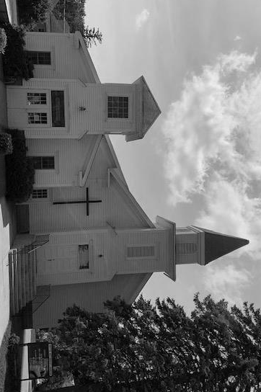
CLEARWATER UNITED METHODIST CHURCH NEWSLETTER – November 2022
Carol Halvorson, Editor,
Carol e-mail: clwtax@frontiernet.net
Carol cell phone - text or call 320-493-4997

WORSHIP SERVICE:
Sundays at 9:30 AM
Come and join us in worship – our attendance is down – we would love to have your presence.
Plan to stay for coffee after in the fellowship hall.
If you haven’t yet, please make a list of 5-10 of your favorite hymns (include your name) and give to the pastor.
This Sunday will be All Saints Day – please bring a picture of a loved one (or ones) to remember for All Saints Day.

WEEKLY BIBLE STUDY:
Mondays at 10:30 AM

HALLOWEEN
Oct 31 – Monday Halloween “Trick or Treat” at the church 5-8 pm to hand out treats. We will be including a slip about our church with the candy treats. Please come and help hand out treats (wear a costume if you are willing).
MONTHLY: United Women in Faith –UMWIF
November 1 - 1st Tuesday of every month at 2:00 pm
After a short meeting we will be continuing to make the fleece mittens for the St. Cloud School District.
We will also be sponsoring a family in the St. Cloud area for Christmas gifts again this year.

MONTHLY-POTLUCK AND MOVIE NIGHT:
First Saturday of each month- Nov 5 at 5:00 p.m. Bring a dish to share and after dinner will be a movie. We’ll have popcorn also.
Invite your friends and family.
HOLIDAY BAZAAR AND BAKE SALE
Saturday, November 19 from 10:00 a.m. to 2:00 p.m. Please contribute baked goods, white elephant items, craft items, Holiday decorations, Christmas gift items. Coffee and apple cider will be offered to encourage shoppers to linger and mingle and socialize. Come and join us – it will be fun.
NOV 25, SATURDAY
10:30 a.m. until about noon. This is the time we need to put up our Christmas tree, as that Sunday will be the first day of Advent. As usual, we need all the help we can get to put up the tree and decorate the rest of the Church for the Christmas season. We especially need someone who can still climb a ladder. Does anyone have some agile teenagers to help? We will plan a light lunch after we’re done!
CHRISTMAS EVE AND CHRISTMAS DAY SERVICES
Christmas Eve service will be at 4:00 p.m. on December 24 and Christmas Day (Sunday, December 25) service will be at the normal time with a short sermon and Christmas carols.

PRAISE GOD!
Fall is here! Winter is not here yet! Let’s enjoy this beautiful country that God has given us in this fall season.

OUR CHURCH WEBSITE: www.clearwaterumcmn.org – Please remember to log in and check it out.

BUDGET OVERVIEW
Our projected budget for 2023 shows $600 more per month of expenses than our projected income. Our utilities and insurance have increased and our giving is down – not a good combination. Please pray about this problem. We do have $ in the bank because in 2021 we did receive the 2 PPP Grants of about $7,800 each plus a small grant from the county. We do need more giving dollars to cover our expenses though.

NOVEMBER BIRTHDAYS:
Margaret Heinks – Nov 14
Carolyn Rinkenberger – Nov 28
Jan Propsma – Nov 30
If we are missing your birthday, please call, text or e-mail Carol and we will add.

SUBMISSIONS:
“The only exercise some folks get is JUMPING to conclusions, RUNNING down their friends, SIDESTEPPING responsibility, and PUSHING their luck.”
“If you aren’t as close to the Lord as you used to be, you can be absolutely certain as to which one of you has moved.”
“Promises are like crying babies in church…..they should be carried out immediately.”

sUBFrom Pastor Alison Hendley
At this time of year I spend a lot of time outside, and enjoy both the warmer days and the cooler ones. The yard chore list is long, the woods are calling with their beauty, the promise of winter in the air makes me want to move before the snow flies. And it is so beautiful. I find myself offering songs and prayers of thanks as I work or walk, touched by the quality of light that feels so healing and the beauty of the leaves as they flutter to the ground.

As Thanksgiving approaches, gratitude is on a lot of people’s hearts. Some of my friends have embarked on a 75 day journey of gratitude on Facebook…. One gratitude posted each day until the end of the year. Others do a month of gratitude throughout November. And some, with high school seniors, are doing a month long challenge of posting what they are grateful to their senior for. But it makes me wonder why we don’t focus on gratitude this much throughout the year. What if we lived our lives being grateful and expressing thanks? What if we lived with an attitude of gratitude, as that old saying goes?

I expect you have all experienced a conversation with someone who is always negative or complaining and how draining it is. How you come away feeling worse than when you began. Or maybe you have caught yourself doing this…. Going about life looking for all the things that are hard or wrong. And then we begin to pay those thing attention then we see more of what is wrong or hard.

Yet if we begin to look for what we are grateful for, we begin to find more things to be grateful for. It’s the bias we have of seeing what we are looking for…. Looking for the good things we see more. Looking for the negative, we see more.

Someone once said, "What would you have if you only had today what you expressed gratitude for yesterday." And it is something to think about!

As November comes, seek things to be grateful for…. And see how these things multiply and become more visible! If you catch yourself complaining pause and find a gratitude If you begin to focus on what’s hard pause and find something that is easier that you can give thanks for. See how your focus helps you notice more things to be grateful for. Express them out loud to those you interact with, and see how contagious your gratitude might be. Give thanks to God for all that God has given you. Notice! And be glad!

http://www.alisonhendleyhealingcom/
"My soul is striving to remember who I am, to make who I am compatible with who I was born to be, to bring who I am into synch with who I will be." Steven Foster

