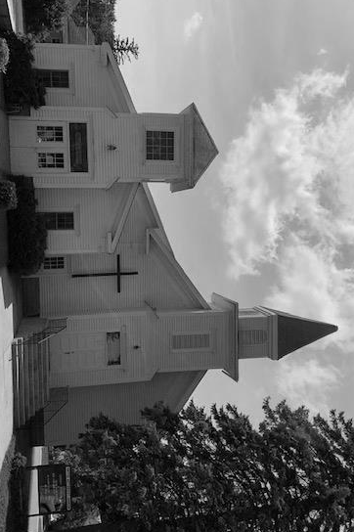
CLEARWATER UNITED METHODIST CHURCH NEWSLETTER – December 2023
Carol Halvorson, Editor,
Carol e-mail: clwtax@frontiernet.net
Carol cell phone - text or call 320-493-4997

WORSHIP SERVICE:
Sundays at 9:30 AM
Come and join us in worship – our attendance is down – we would love to have your presence.
WEEKLY BIBLE STUDY:
Mondays at 10:30 AM
CHRISTMAS EVE WORSHIP
December 24 at 4:00 p.m.
Please come and bring family/friends!
PRAISE GOD!
For a very long and beautiful fall! We can wait patiently for the snow and cold!
For a blessed Christmas Season that is fast approaching. Advent begins December 3!
For the successful ANNUAL HOLIDAY BAZAAR, LUNCH AND BAKE SALE ON NOVEMBER 11.
OUR CHURCH WEBSITE: www.clearwaterumcmn.org – Please remember to log in and check it out.
BUDGET OVERVIEW
Our projected budget for 2023 shows $600 more per month of expenses than our projected income. Please pray about this problem. We do have $ in the bank because in 2021 we did receive the 2 PPP Grants of about $7,800 each plus a small grant from the county. We do need more giving dollars to cover our expenses though. Through October of 2023 our income and expenses were about the same as 2022, however there is a shortfall for both years.
We had a meeting with our District Superintendent in November and he was very supportive and had good things to say about our church mission.
DECEMBER BIRTHDAYS:
Judy Martin – Dec 10
Marshall Rinkenberger – Dec 13
Jenealyn Mitchell – Dec 19
Dick Powell – Dec 27
Vi Bentley – Dec 28
If we are missing your birthday, please call, text or e-mail Carol and we will add.
ANNOUNCEMENTS:
December 2 at 10:30 a.m. we will be decorating the church for Christmas. We appreciate any help that you can give. A lunch will be provided.
January 7, we will be taking down the Christmas decorations, please come and help with this also.
FOR NEXT NEWSLETTER –
Please send by e-mail or call Carol with any announcements, articles, projects, thoughts, recipes, etc.
If you would like to be taken off of the newsletter list please respond to Carol. There are many on the email list that are inactive. If you are interested in our church mission we would appreciate your financial support. If you are not interested in our mission we will take you off of the mailing list.
Angel Family that we will be supporting for Christmas 2023:
2023 SCSD FAMILY FOR CHRISTMAS

11 year old girl.

Jogging suit/sweat suit size 16 or youth XL (she is tall).

Jewelry

any kind of craft kit and baby dolls.

6 year old girl.

Size 12 clothes.

Easy bake oven

baby doll.

Mom –anything

Gift cards for Target, Walmart, etc are especially helpful.

There will be a sign up sheet of this list at the church and the gifts (unwrapped) can be brought to church and given to Carol who will deliver to the representative for the SCSD.

Recipes
Pumpkin Cake/ or Bars
Mix together
1 15 oz can pumpkin
4 eggs
½ cup oil
½ cup buttermilk
2 cups sugar
Add and mix in
2 cups flour
½ teaspoon salt
2 tsp baking powder
1 tsp soda
2 tsp cinnamon
Nutmeg, ginger, cloves
Bake in large cake pan (or larger sheet pan for bars) for 30-45 minutes or until toothpick comes out clean.
Cool and frost:
4 oz cream cheese and ¼ cup butter mixed together. Add and mix in 1 tsp vanilla and 1 ½ cups powdered sugar. (double for sheet pan)

……………From Pastor Alison Hendley……………

The Holiday season is upon us…. For you is it a time of celebration or stress? Wondering how to get everything done and how to pay for it all, and how to deal with those family members who are challenging for you to be at table with, or a time to rejoice in the busy-ness of concerts and shopping and extra cleaning and shopping and travel and cooking. Or maybe it’s a time when the grief of those no longer here feels especially sharp as you turn to an empty chair to laugh or cry at a ‘that’ scene in the movie you laughed or cried at together each year, the loss striking you afresh. No matter which category the holiday season brings you to, we can all probably agree that it can be hard.

Jan Richardson reminds us that Advent is this time to wait in the midst of the busy season. To rest, to listen, to pay attention, to prepare inwardly (so different from preparing outwardly) for Christ to be born. She writes:

“The season of Advent means there is something on the horizon the likes of which
we have never seen before… .
What is possible is to not see it, to miss it, to turn just as it brushes past you.
And you begin to grasp what it was you missed, like Moses in the cleft of the rock, watching God’s [back] fade in the distance.
So stay.
Sit.
Linger.
Tarry.
Ponder.
Wait.
Behold.
Wonder.
There will be time enough for running. For rushing. For worrying. For pushing.
For now, stay.
Wait.
Something is on the horizon.”

At Clearwater we are practicing our presence with God during the Advent season and noticing the difference it makes when we seek and sit with hope, peace, joy, love and light. Join us as we explore these on Sunday mornings.
Our Christmas Eve worship will be at 4:00pm on Sunday 24th…. Don’t forget to invite a friend or two to join you to celebrate!

